Welcome!

And Thank You for the very positive feedback from our new Newsletter.

Regeneration of the Station building continues at some pace, despite the restrictions that we are all under – we have cleared an awful lot of the rubbish accumulated over many years – but make no mistake, everything that has value or links to the past is being well cared for!

*****************************************The GOOD NEWS is that, – following the latest updated Government Guidelines - we are now able to plan “Volunteer Events”
Our first “Volunteer Weekend” will be on

Saturday and Sunday the 18th / 19th July
10am to 3pm

We are having an outdoor weekend – focussed upon clearing debris and tidying the weeds on the former 5-a-side pitch / car park area.
This will not only make “social distancing” easier for our Volunteers, but also improve things for our friends and neighbours “next door”. So…..

PLEASE CAN YOU HELP?

Send an email to gedlingyouth@gmail.com letting us know your preferred day / time (AM or PM).
To comply with Government Guidance please :
- Please bring along your own gardening gloves / spade / rake / tools etc.
- Usually we will happily provide coffee / tea – but we need to ask that you bring your own mug.
- If you require a face mask – please bring your own.

We have made some excellent progress over recent months – this is your opportunity to come and support us in our efforts to regenerate the old Station building into a thriving Community Hub – please come and lend a hand, even if it is just for a few hours – you will be more than welcomed!
Volunteers – Young and Old………
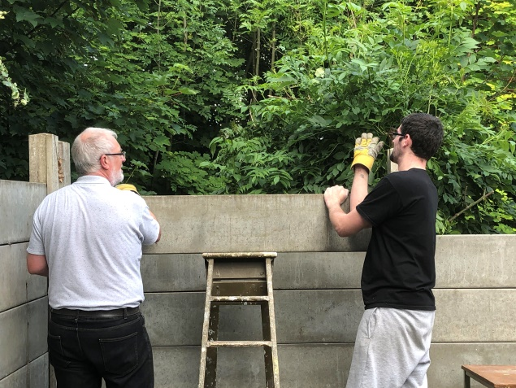
Keep an eye on our Noticeboard – for latest Events
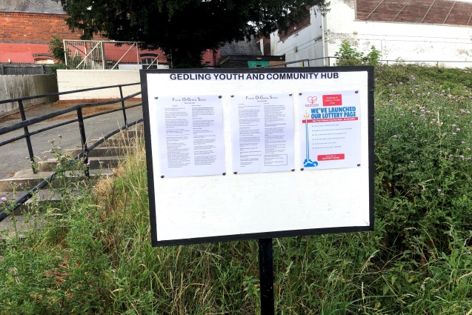
Our request for skilled help has resulted in a good number of local small businesses coming forward to offer their services – Thank You….. if you feel that you and your business can maybe help us – please get in touch ; gedlingyouth@gmail.com.
Fundraising (1)
We have been fortunate to receive a grant from Gedling Borough Council which will help progress the surveys and essential works around the building over the coming months….all aimed at us being in a position to provide a valuable community hub at some point in 2021. We have already had approaches from a few groups who are very keen to use our rooms / gym…..watch this space!
July / August in Days Gone By……..
July 1871 Lady Bay Bridge opens for rail traffic for the first time
August 1876 The passenger service through Gedling Station opens
August 1951 All traffic comes to an end on the Nottingham Suburban Railway

Fundraising (2)

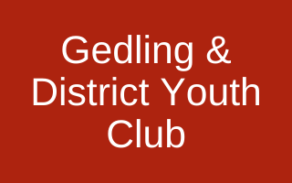
You can now help our cause with the Gedling Lotto scheme.
Tickets cost just £1 per week, with 50% of that going direct to us to help improve and transform the Gedling & District Youth Club.
Furthermore, 10% will be shared out to other local causes within Gedling.
The best part about your donation is that you will be entered into a lottery to win up to £25,000!
Each ticket has a 1 in 50 chance of winning each week – that’s a better chance than winning the National Lottery!
How it works:
Each ticket will consist of 6 numbers and each number will be between 0 and 9. There will be a draw every Saturday night when a 6 digit winning combination will be picked. Prizes will be given to players with tickets that match the first or last 2-6 numbers from the winning combination. Match all 6 and you win the JACKPOT!
To join the lottery, click here to visit our page on the Gedling Lotto site – Good Luck!

Excellent Engineering on the Derbyshire Extention
Does anyone remember Giltbrook viaduct?
It was one of several magnificent engineering projects undertaken by the Great Northern Railway on the line on which Gedling Station was built. It was designed by Richard Johnson, Chief Civil Engineer of the Great Northern Railway and constructed between May 1873 and November 1875. Resident engineer of the project was Samuel Abbott and the work was undertaken by contractor Joseph Firbank.
This impressive structure extended for 572 yards along the Pinxton branch and was known locally as ‘Forty Bridges’. There were 43 red brick spans elevating the track 60ft above the ground. The 30ft wide arches were separated by single spans crossing roads, canals and other railway lines beneath. Two of the spans were converted into dwellings which were used as air raid shelters during the Second World War. Giltbrook viaduct was demolished in 1973 to make way for the A610.
Nearby Newthorpe and Greasley Station suffered a similar fate in the same year.
Brian Howes (Chair: Gedling Village Local History & Preservation Society)
We hope that you find this Newsletter interesting – maybe you will be able to come and take a look at our project, and come and lend a hand over coming weeks and months!
Take Care – from all at Friends of Gedling Station

